Space Odyssey

Game Design Document

Christian De La Torre

Game Overview

Title: Space Odyssey

Platform: MacOS Standalone

Genre: Space platformer

Rating: (10+) ESRB

Target: Casual gamer (aging 12 – 100)

Release Date: December, 2018

Publisher: Christian De La Torre

Space Odyssey is a 2D platformer where the player is a stranded astronaut who has lost his way along the outmost reaches of space. In order to get back to his homeland, the astronaut must collect all the special coins at the end of each level in order to proceed onto the next one. Players will encounter different moving blocks and different friction levels depending on the area or location and different objects that can cause the player to respawn at the beginning of the level. There are no allies so it is up to the lonely astronaut to make back to his homeland in one piece, or die trying.

Unique Selling Points

* Fun for all ages
* User friendly and easy to follow instructions
* Variation of music per scene
* Challenging levels to get the player intrigued
* Multi-level scenes

Platform Minimum Requirements

* Mac standalone
* OS: Mac OS X 10.8+
* Graphics Card: A potato

Synopsis

You have gotten lost after exploring deep into the unknown that is space. You land on a red planet which tells you that you must collect the special coins located on each planet in order to get back home. But be careful of the environment and the objects ready to bring you down. Now it is just you and space, one-vs-one.

Game Objectives

The objective of the game is to jump platform to platform in order to collect the special coin and advance. All while looking out for moving platforms and pointy objects that will restart the astronaut.

Game Rules

Complete the level by collecting the coins at the end of each scene. Make sure to not fall or touch the spikes or you will die and restart at the beginning of the game.

Game Structure

Option Menu

Main Menu

End Credits

Final Level

Level Two

Level One

Introduction

Gameplay

Right Arrow – Move Right

Left Arrow – Move Left

Space – Jump

Game Camera

The camera will be pointed at the player at all times and the background and objects will stay following the camera as they are both locked in.

Player

Player Characters

* The Astronaut

Player Metrics

* N/A

Player States

* **Move**: The movement animation will cause the character to move both hands and legs at a faster rate to have the effect of a small person having to take multiple steps to get far. It will be triggered when the Player moves the character.

Player Weapons

* N/A

Character Line-up/Enemies

 Astronaut: Main playable character and only character

Art

Setting

* The game takes place in space with each scene being a different galaxy/location in space. After collecting each coin, the player to transported to the next coin location. Because the astronaut is so small, the environment gives off a bigger perspective and different platforms will cause different effects on the character. For example, ice will cause the player to have less friction, and stepping on the teeth in the live skin location will cause insta-death.

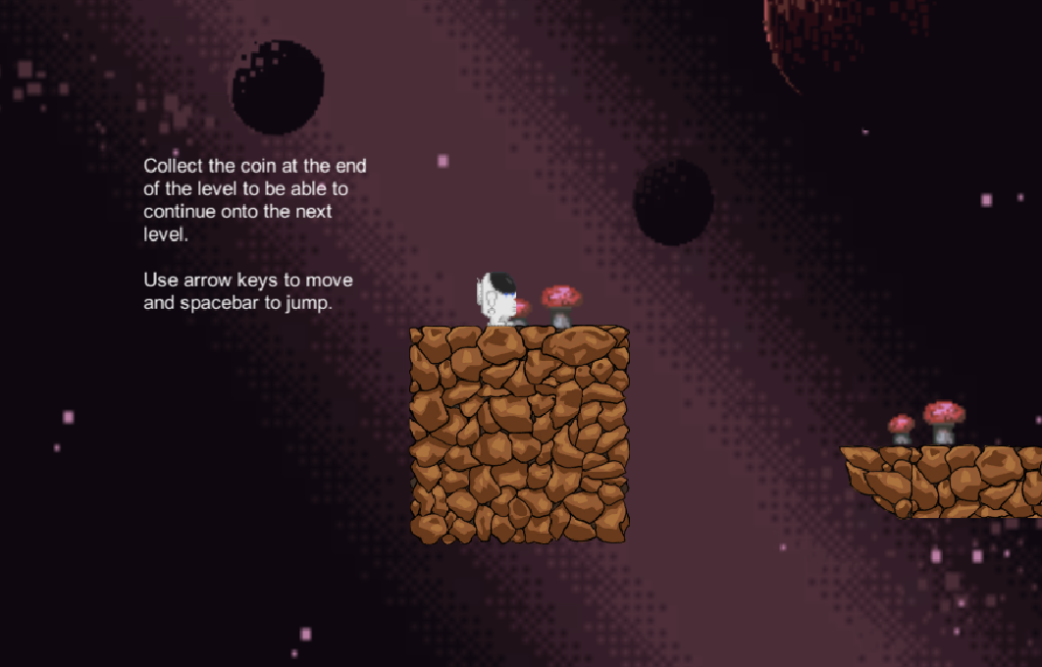

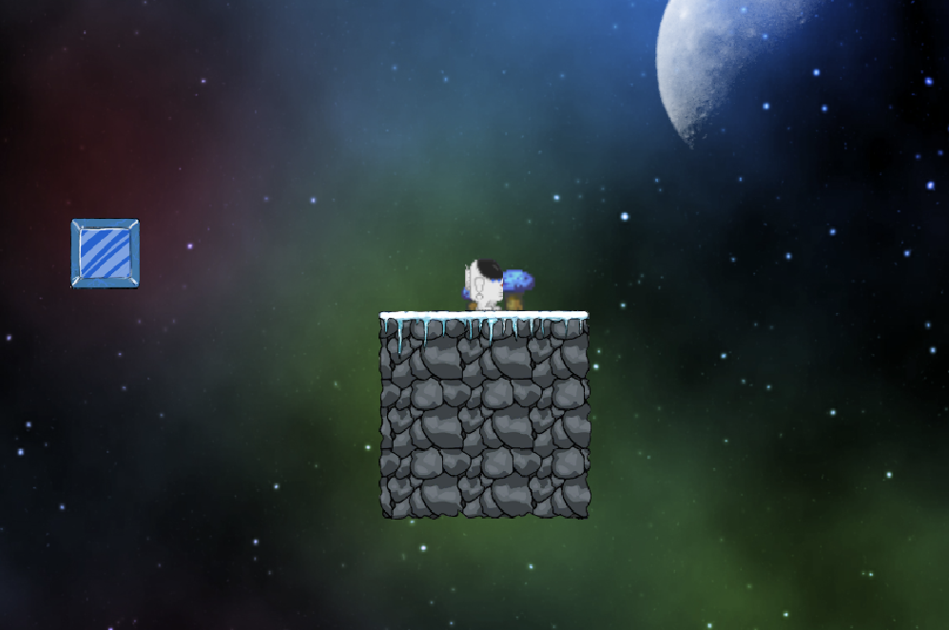

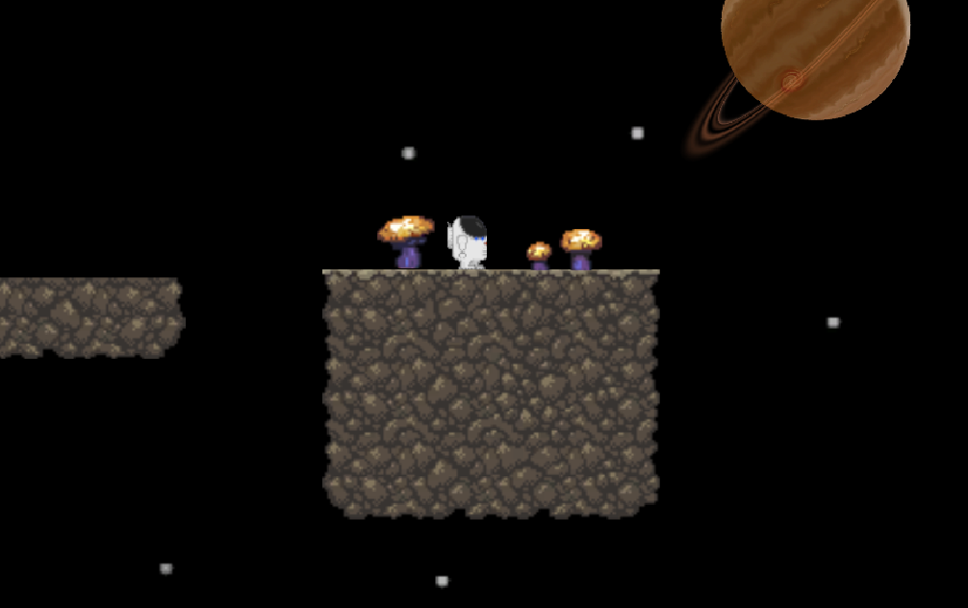

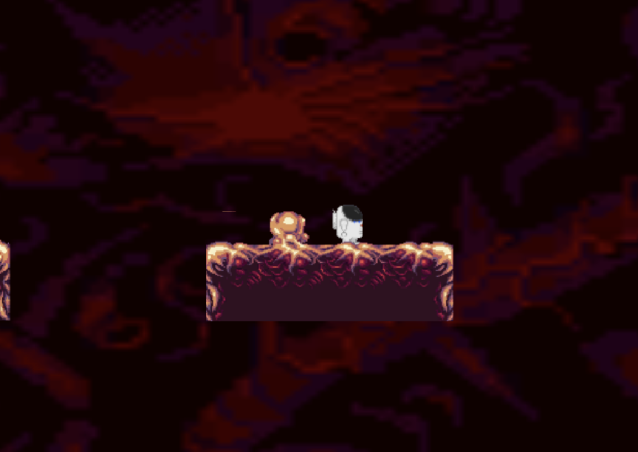

Level Design

The introduction level consists of the Red Planet. With red rocks as the platforms and the red platform as the indication of the final location. The mushrooms are a way of guiding the character along the correct path to the coin. The first level consists of the Blue/Ice Planet. With the ice cubes causing the player to experience friction and the blue mushrooms as a form of guidance. The second level consists of the Yellow Planet. The rocks are of neutral color and will be moving at a more difficult rotation and most other platforms. The final level is considered the inside the monster level. The teeth will cause instant death when touched and there are certain teeth that are no hurtful and other teeth that are hurtful.

Audio

Name Category Description

hbs Background music Plays during game

Ominous Goings-On Background music Plays during game

space rock Background music Plays during game

World Travel Background music Plays during game

ancientbgm Background music Plays during game

Death Is Just Another Path Background music Plays during game

seven_and_eight_7-8_combined Background music Plays during game

MVP (Minimum Viable Product)

* One Player character which is the Astronaut
* Built for the Mac OS Platform

Wishlist

ADD ENEMIES

Be able to add enemies to the game in order to increase the difficulty of the game with each different behaviors

ADD MORE SOUND EFFECTS

Add different sounds for different effects such as death, enemies, footsteps, coin picking, and so on.

ADD MORE LEVELS

Create more levels and depending on the characters level of skill build a map according to the players skill level.

Bibliography

Initial Script and Asset Bibliography:

* Author: MrGecko
  + <https://opengameart.org/content/astronaut-0>
* Author: Marta Nowaczyk / Aetherna
  + <https://opengameart.org/content/2d-platform-winter-tiles>
  + <https://opengameart.org/content/2d-platform-ground-stone-tiles>
* Author: surt
  + <https://opengameart.org/content/platshrooms>
* Author: Loel
  + <https://opengameart.org/content/coins-pixel-art-silver-gold-crystal-and-more>
* Author: Luis Zuno / ansimuz
  + <https://opengameart.org/content/living-tissue-platform-tileset>
  + License: CC-BY-3.0 License <http://creativecommons.org/licenses/by/3.0>
* Author: Amon
  + Amon.co
  + Imagination-engineer.com
  + <https://opengameart.org/content/orbs-and-plats>
* Author: Stephen Challener (Redshrike[T3h Luggage])
  + <https://opengameart.org/content/scifi-creature-tileset-mini-32x32-scifi-creature-icons>
* Author: Luis Zuno / ansimuz
  + <https://opengameart.org/content/space-background-3>
* Author: bart
  + <https://opengameart.org/content/moon-overlay-texture>
* Author: Graul98
  + <https://opengameart.org/content/star-field>
* Author: Rawdanitsu
  + <https://opengameart.org/content/starfields>
* Author: Cougarmint
  + <https://opengameart.org/content/tangeron-another-2-d-planet>

Sounds

* Artist: Otto Halmen
  + <https://opengameart.org/content/death-is-just-another-path>
* Artist: Aspecty
  + <https://opengameart.org/content/suspenseheartbeat-soundtrack>
* “Ominous Goings-On” by Eric Matyas
  + <https://opengameart.org/content/ominous-goings-on>
* Artist: Dan Knoflicek / Macro
  + <https://opengameart.org/content/world-travel>
* Artist: Monster Logix Studio
  + <https://opengameart.org/content/retro-space-bgm>
* Artist: The Cynic Project/pixelsphere.org/cynicmusic.com
  + <https://opengameart.org/content/icy-realm-seven-and-eight>
* Artist: Heathal
* <https://opengameart.org/content/space-rock>